Name: ___________________

NetID: ___________________

Discussion Section: _________

Linguistics 1010

Make-Up Assignment

Week 12

**Part I: Introduction to the brain**

1. Briefly describe what happened to Phineas Gage and why this story is relevant for this class.
2. Briefly describe what happened to Henry Molaison and why this story is relevant for this class.
3. Label each of the following highlighted functional cortices:

1. ______________ 2. ______________

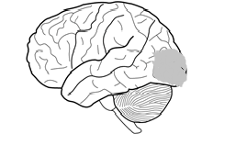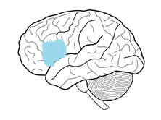

3. ______________ 4. ______________ 5. ______________

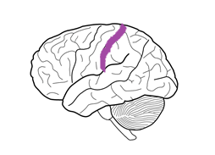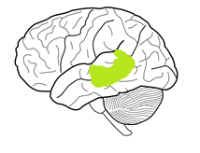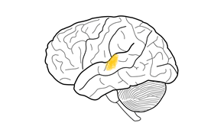

1. In the figure below, each of the lobes of the brain is distinctly colored. Label each lobe:

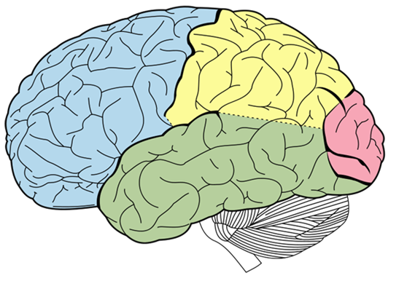

Blue: ______________

Yellow: ______________

Green: ______________

Pink: ______________

1. In the figure below, name the two sulci that are indicated with colored lines using the naming conventions that we learned in lecture:



Red sulci: __________

Purple sulci: _________

1. Name the disorder for each of the symptoms below.
2. Letters appear to jump around the page. ______________
3. Trouble imagining a tranquil beach. ______________
4. Failure to recognize yourself in older photographs. ______________
5. The world appears as if it is lit with a strobe light. ______________

**Part II: Language and the brain**

1. Name the language disorder for each of the sets of properties below:
2. Muscle weakness of the vocal tract due to damage to

the nervous system. ______________

1. The production of fluent, but meaningless, sentences,

and difficulty comprehending speech. ______________

1. Difficulty producing fluid speech and comprehending

complex syntax. ______________

1. Paralysis of the vocal tract due to damage to the motor

cortex. ______________

1. Difficulty naming certain objects. ______________
2. General impairment of mental abilities that sometimes

impact language. ______________

1. Is caused by damage to the Left Inferior Frontal

Gyrus. ______________

1. Is caused by damage to the Posterior Superior Temporal

Gyrus. ______________

1. Determine if the following statements about Wernicke’s Aphasia are TRUE or FALSE. If you choose to answer FALSE, please briefly explain why.
2. Wernicke’s Aphasia is associated with a lesion to the anterior inferior occipital gyrus.
3. Wernicke’s Aphasia is sometimes called non-fluent aphasia.
4. Carl Wernicke found that all language disorders result from a lesion to Broca’s area.
5. There are elements that seem to suggest that Wernicke’s Aphasia is an impairment of speech processing.
6. For each of the statements below, indicate whether it is a property of MRI or fMRI by writing MRI or fMRI after it.
7. Generates images by measuring the density and location of

hydrogen atoms. _______________

1. Generates images by measuring the density and location of

deoxygenated hemoglobin. _______________

1. Images must be composed in 2D “slices” that are either axial,

coronal, or sagittal. _______________